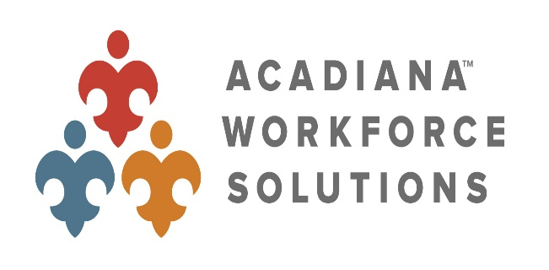

Local Workforce Development Board #40
1638 Creswell Lane Ext.; Ste. 1
Opelousas, Louisiana 70570
Phone: (337) 284-0505 Fax: (337) 284-0505
www.acadianaworkforce.org

AGENDA
LWDB #40 BOARD OF DIRECTOR’S MEETING
August 24, 2022 - 10:00 AM
U of L @ Lafayette Student Union, Atchafalaya A
624 McKinley Street, Lafayette, LA

- CALL MEETING TO ORDER
- PLEDGE OF ALLEGIANCE
- ROLL CALL
- WELCOME/INTRODUCTION OF NEW BOARD MEMBER
- MINUTES FROM PREVIOUS MEETING (ACTION)

- LOCAL WORKFORCE DEVELOPMENT REGION 4 – EXECUTIVE DIRECTOR’S REPORT
- FINANCE COMMITTEE REPORT (ACTION)
- ONE-STOP DELIVERY SYSTEM COMMITTEE REPORT (ACTION)

- BOARD COMMITTEES

- UPCOMING EVENTS/UPDATES/REMINDERS

- NEW BUSINESS

- OTHER BUSINESS

- PUBLIC COMMENT
- ADJOURN (ACTION)

